IFTS / Institut de Formation et de Thérapie pour Soignants

Psychodermatology consultations
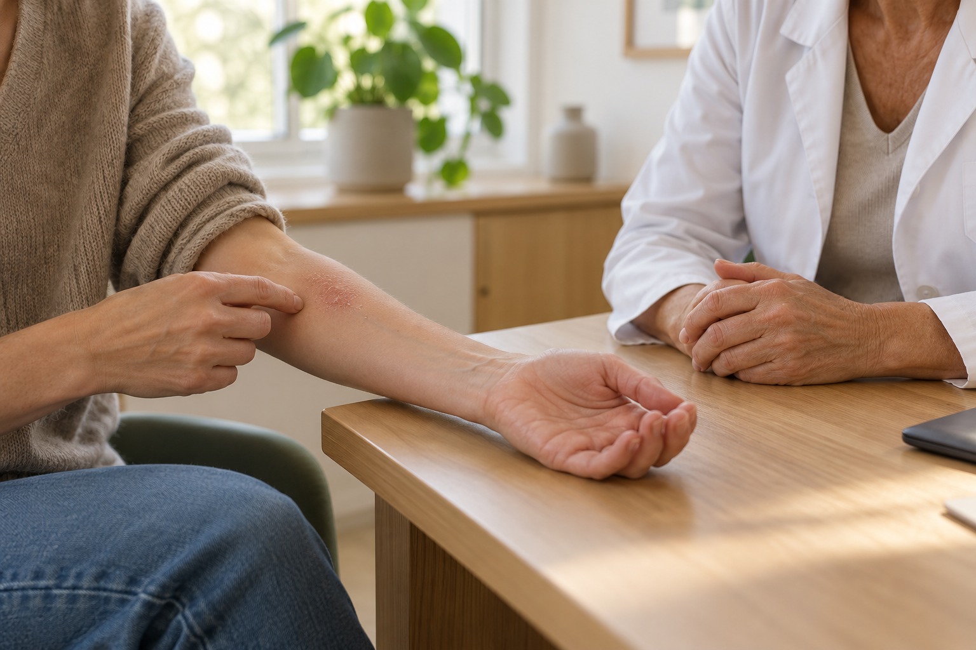
Itching that keeps you awake, eczema or psoriasis that flares up during a difficult time, visible skin changes that make you feel self-conscious around others… Skin problems can affect many aspects of everyday life.
At IFTS, Dr Françoise Poot offers psychodermatology consultations. As a dermatologist and systemic psychotherapist, she can help you explore both your skin symptoms and how they affect you in a single consultation.
At your first appointment, we start with what brings you here. We take time to talk about how your symptoms have changed, which treatments you have tried and what you find most difficult at the moment. Depending on your situation, we may also explore what happens during a flare-up, when the urge to scratch feels hard to resist, or how your skin condition affects your family life, your work or your intimate relationships.
Together, we discuss what you would like to change and agree on care that suits you and complements your ongoing dermatological care.

Booking an appointment
To book an appointment with Dr Françoise Poot, call 0476 22 65 44 from Belgium or +32 476 22 65 44 from abroad.
You can see Dr Poot in person at her practice. Video consultations are also available. If you would prefer a video appointment, please mention this when you call.

